Year 12 Chemistry Topic Test #3 - 2011

Name:__________________________________ Mark = _____ / 57

Part 1: Multiple Choice Section 10 marks
______________________________________________________________________________

- Which of the following exhibits geometrical isomerism?

A. trifluoroethene
B. 1-chloro-2-bromoethane
C. methylpropene
D. pent-2-ene

- Which of the following is a tertiary alcohol?

A. cyclobutanol
B. 2-methylcyclobutanol
C. 1-methylcyclopentanol
D. dimethylpropan-1-ol

- Addition of hydrogen chloride to propene can produce which of the following substances?

I. 1-chloropropane
II. 2-chloropropane
III. 1,2-dichloropropane
IV. 2-chloropropene

A. I and II
B. I, II and III
C. II only
D. II and III

- The oxidation of butan-2-ol with acidified potassium permanganate will produce?

A. butanoic acid
B. butanal
C. butanone
D. no reaction

The following two questions are about aspirin;

5. Aspirin contains the following substance:

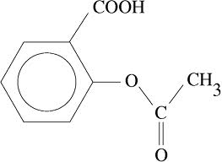

Which of the following functional groups does aspirin contain?

I. aldehyde
II. ketone
III. carboxylic acid
IV. ester

A. II and III
B. III and IV
C. I and II
D. all of them

6 Aspirin can be manufactured from salicylic acid, whose structure is given below:

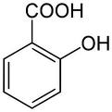

To convert salicylic acid into aspirin, what other substance should it be reacted with?

A. ethanol
B. ethanoic acid
C. acidified potassium dichromate
D. sodium hydroxide solution

- The empirical formula of 1,4-dimethylbenzene is:

A. C₄H₅
B. C₆H₁₀
C. C₈H₁₀
D. CH₂
8. Which of the following is not an isomer of the other three?

A. butanoic acid
B. 2-propyl methanoate
C. butan-1,2-diol
D. methyl propanoate

9. Which of the following represents a soap?

A. CH₃(CH₂)₁₆COOK
B. NaOH
C. CH₃COONa
D. CH₂OH
|
CHOH
|
CH₂OH

10. Which of the following reactants are capable of forming a condensation
polymer under suitable conditions?

A. HOCH₂CH₂CH₂CH₂CH₂CH₂CH₂COOH

H H
\ /
B. C=C
/ \
H C

H H
\ /
C. C=C
/ \
H C=O
I
O
\
CH₃

D. HOOCCH₂CH₂CH₂CH₂CH₂CH₂CH₂COOH

and

HOOCCH₂CH₂CH₂COOH

Part 2: Short Answer Section 47 marks
______________________________________________________________________________

11. Name and draw full structural formula to represent the following substances;

A saturated isomer of C₄H₈

An alkene with 4 carbon
atoms that does not exhibit
geometric (cis/trans) isomerism

The product of reacting
cis-pent-2-ene with hydrogen

A structural isomer of
methyl methanoate that fizzes when added to sodium carbonate solution

An amine with 5 hydrogen atoms

The organic product formed when
one molecule of cyclohexane
reacts with one molecule of chlorine
in the presence of UV light

(12 marks)
12. Complete the following table.

Molecule | Major type of intermolecular attraction  (choose from dispersion forces,  dipole-dipole or hydrogen bonding) | Boiling point ranking  (1 = highest, 5 = lowest)
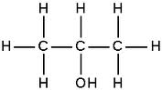
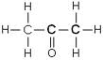
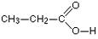
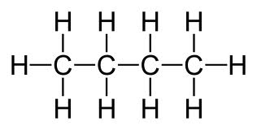
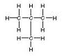

(8 marks)

13. The structures of glycine and alanine are shown below:

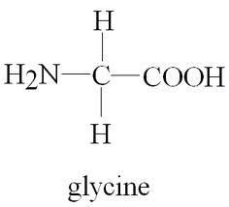 | 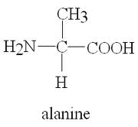

(a) To which class of compounds do they both belong?

__________________________________________________________________
(1 mark)

(b) What is the main intermolecular force between alanine molecules?

__________________________________________________________________
(1 mark)

(c) A glycine molecule and an alanine molecule can react with each other in a
condensation reaction to form a new substance called a dipeptide.

Draw one of the two possible dipeptides that could be formed below.

(3 marks)
14. There are four isomeric alcohols, all of which have the molecular formula, C₄H₁₀O.

Draw each of these alcohols, and draw their oxidation product(s) when reacted with
acidified potassium dichromate solution.

Alcohol | Oxidation product(s)

10 marks

15. 2.19 g of an organic compound X is completely burnt in excess oxygen, forming 3.21 g of
carbon dioxide and 1.32 g of water.

(a) Calculate the empirical formula of X.

(7 marks)

In a second experiment it was found that 0.473 g of X occupied 278 mL, measured at
200ºC and 1.10 atm.

(b) Calculate the molecular formula of the compound.

(3 marks)

(c) Given that, at STP, X is a sweet smelling liquid, draw the structural formula of
X and name it.

(2 marks)

End of Test

SVACS

Year 12 Chemistry Topic Test #3 - 2011

Name: ANSWERS Mark = _____ / 57

Part 1: Multiple Choice Section 10 marks
______________________________________________________________________________

1. D 2. C 3. A 4. C 5. B 6. B 7. A 8. C 9. A 10. A

Part 2: Short Answer Section 47 marks
______________________________________________________________________________

11. Name and draw full structural formula to represent the following substances;

A saturated isomer of C₄H₈ |  | 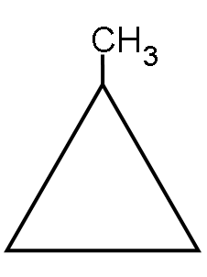
 | cyclobutane | methylcyclopropane
An alkene with 4 carbon  atoms that does not exhibit  geometric (cis/trans) isomerism | 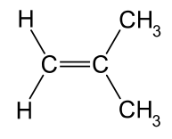 | 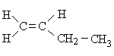
 | methylpropene | 1-butene
The product of reacting  cis-pent-2-ene with hydrogen | 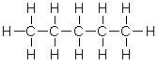
 | pentane
A structural isomer of  methyl methanoate that fizzes when added to sodium carbonate solution | 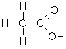
 | ethanoic acid
An amine with 5 hydrogen atoms | 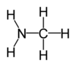
 | methanamine
The organic product formed when  one molecule of cyclohexane  reacts with one molecule of chlorine  in the presence of UV light | 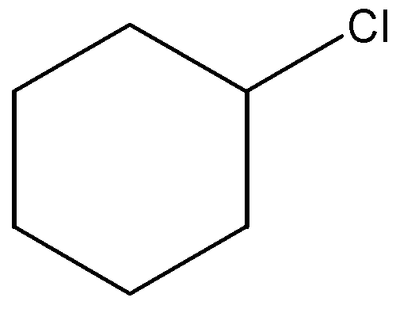
 | chlorocyclohexane

each (12 marks)
12. Complete the following table.

Molecule | Major type of intermolecular attraction  (choose from dispersion forces,  dipole-dipole or hydrogen bonding) | Boiling point ranking  (1 = highest, 5 = lowest)
 | hydrogen bonding | 2
 | dipole-dipole forces | 3
 | hydrogen bonding | 1
 | dispersion forces | 4
 | dispersion forces | 5

each (8 marks)

13. The structures of glycine and alanine are shown below:

 | 

(a) To which class of compounds do they both belong?

Amino acids
(1 mark)

(b) What is the main intermolecular force between alanine molecules?

Hydrogen bonding

(1 mark)

(c) A glycine molecule and an alanine molecule can react with each other in a
condensation reaction to form a new substance called a dipeptide.

Draw one of the two possible dipeptides that could be formed below.

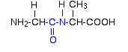 | 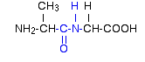

(3 marks)
14. There are four isomeric alcohols, all of which have the molecular formula, C₄H₁₀O.

Draw each of these alcohols, and draw their oxidation product(s) when reacted with
acidified potassium dichromate solution.

Alcohol | Oxidation product(s)
CH₃CH₂CH₂CH₂OH  (1-butanol) | CH₃CH₂CH₂CHO | CH₃CH₂CH₂COOH
CH₃CH₂CHOHCH₃  (2-butanol) | CH₃CH₂COCH₃
CH₃CH(CH₃)CH₂OH  (methyl-1-propanol) | CH₃CH(CH₃)CHO | CH₃CH(CH₃)COOH
CH₃CH(OH)(CH₃)CH₃  (methyl-2-propanol) | none

each (10 marks)

15. 2.19 g of an organic compound X is completely burnt in excess oxygen, forming 3.21 g of
carbon dioxide and 1.32 g of water.

(a) Calculate the empirical formula of X.

C | H | O
m(C) = $\frac{12.01}{44.01}$ x m(CO₂)  = 0.876 g | m(H) = $\frac{2.016}{18.016}$ x m(H₂O)  = 0.148 g | m(O) = 2.19 – m(C) – m(H)  = 1.166 g
n(C) = 0.876 / 12.01  = 0.0729 | n(H) = 0.148 / 1.008  = 0.1465 | n(O) = 1.166 / 16  = 0.0729
0.0729
1 | 2 | 1

∴ EF = CH₂O

(7 marks)

In a second experiment it was found that 0.473 g of X occupied 278 mL (= 0.278 L),
measured at 200ºC (= 473.1 K) and 1.10 atm ( = 1.10/1 x 101.3 = 111.4 kPa).

(b) Calculate the molecular formula of the compound.

n = PV/RT = (111.4 x 0.278)/(8.315 x 473.1) = 0.00787 mol

M = m/n = 0.473 / 0.00787 = 60.1 g mol^{–1}

M/EFM = 60.1 / 30.026 ≈ 2

∴ MF = 2 x EF = C₂H₄O₂

(3 marks)

(c) Given that, at STP, X is a sweet smelling liquid, draw the structural formula of
X and name it.

∴ ester

methyl methanoate

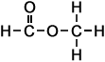

(2 marks)

End of Test

